We require all staff to use MFA when connecting via the VPN. This means you will need to install the Okta app on your smart phone, and set up the authenticator settings in the Okta web portal. Please follow the instructions below.

If you have any questions in the first instance please contact the service desk, if there are any questions.

**Setting up Okta:**

**Step 1:** Navigate to <https://tsg-global.okta.com>

**Step 2:** Sign in with your TSG email address and password

**Step 3:** In the top right of the screen select the drop down on your name and click "Settings"

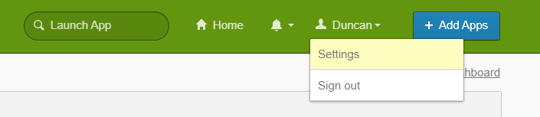

**Step 4:** Select "Set up" under Extra Verification next to "Okta Verify"

**Step 5:** Begin the MFA/Okta Verify enrolment process by clicking on "Setup"

**Step 6:** Choose your mobile OS and click "Next"

**Step 7:** Install Okta Verify App on your mobile and launch the App.

**Step 8:** Choose account type "Organisation"

**Step 9:** Select "Scan a QR Code" and scan the QR code from your Okta browser session.

**Registration should now be complete.**

**Additional Step for connecting to the VPN using Okta:**

Open the Forticlient VPN app on your PC or Laptop. Click on the ‘Remote Access’ tab on the left, then click ‘SAML Login’:

Next, you will be presented with a series of menus asking for your username and password. Enter the username and password that you use to login to your computer, then click ‘Verify’:

Once you’ve clicked ‘Verify’, click ‘Send Push’ to send a sign-in request to your smart phone:

Acknowledge the request on your mobile device:

Congratulations, you’re now connected to the VPN:

